- Implemented features / Completed Work and Design Decisions

In this sprint, the primary focus is backend integration and establishing a robust deployment pipeline, following the goals set in the previous retrospective.

A Flask application was developed to serve as the core backend. To handle data distribution, two main services were established: a Weather API Service that directly calls the OpenWeatherMap API to return JSON data without database intervention, and Station Read APIs that connect to the MySQL database populated during Sprint 1 to return real-time station and availability rows.

The “Journey Planner” feature is involved in the design decision. Additionally, User Authentication was integrated into the system. This includes registration and login endpoints utilising JWT token creation and password hashing to ensure secure access.

For the project’s technical infrastructure, a git feature branch workflow was defined to streamline collaboration. A CI/CD pipeline was configured using a Jenkinsfile to enforce build checks on every branch. Automated deployment to an AWS EC2 instance is now triggered upon merging to the main branch, utilising wsgi.py and Gunicorn to run the application reliably. Finally, on the frontend side, an interactive feature was implemented to display detailed station information when triggered by the user.

- Burndown chart
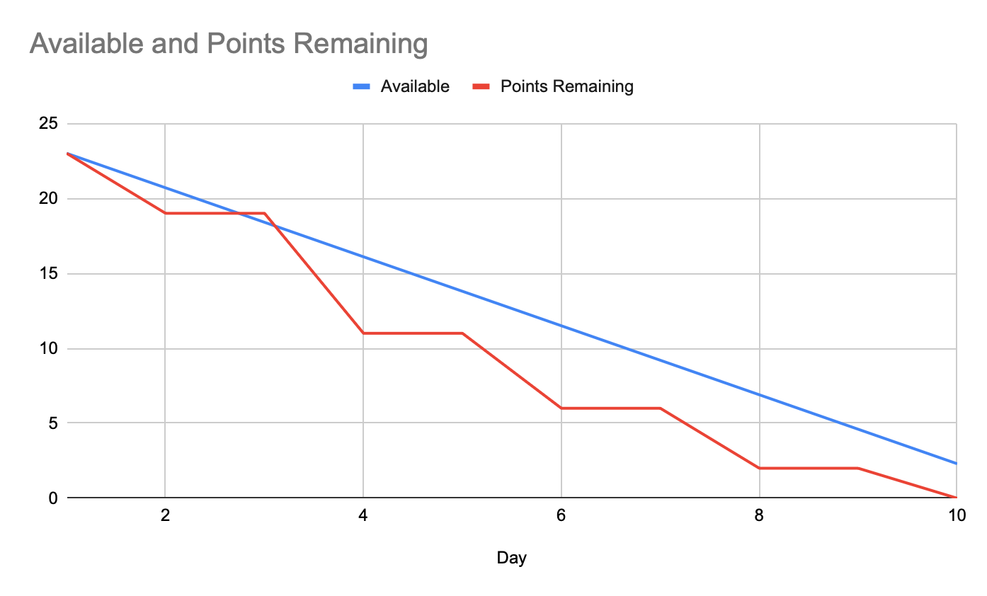
The burndown chart displays a staircase pattern which directly reflects the project requirement to update the chart every two days. Despite these mandated reporting intervals, the actual remaining effort dropped below the ideal available trend line by Day 4 and remained beneath it for the rest duration of the sprint. This demonstrates that a strong development velocity was maintained by the team. All sprint goals were completed by Day 10.

- Sprint Review
API Demonstration: Showcased the operational Weather and Station Read APIs successfully returning properly formatted JSON data from both live external APIs and the local MySQL database.
Security & Authentication: Demonstrated the user authentication flow, highlighting the successful generation of JWT tokens upon login and the secure hashing of passwords in the database.
Pipeline Verification: Conducted a live demonstration of the CI/CD pipeline. A code push was shown triggering a Jenkins build, which subsequently deployed the updated Flask application to the EC2 instance automatically.
Scope Confirmation: Confirmed the successful inclusion and basic backend functionality of the Journey Planner endpoint, finalizing the open discussion from Sprint 1.

4. Sprint Retrospective
What went well:
The transition to backend development was highly successful. Establishing a Git Feature Branch Workflow and a Jenkins CI/CD pipeline accelerated the testing phase and automated EC2 deployments. Furthermore, resolving the scope early allowed for the successful delivery of complex backend features, specifically the Journey Planner and secure User Login.
What could be improved:
API endpoints for frontend-backend interaction lacked initial documentation. This forced frontend developers to manually review the backend code to identify the correct routes for the interactive map features. Additionally, the initial Journey Planner codebase failed to cover several edge cases and contained flawed route calculation logic, which demanded a significant amount of time for refactoring and code improvement.
For next sprint:
Front-end Implementation: The user-facing interfaces for both the Journey Planner and User Login will be developed utilizing React.
System Refinement: The database architecture will be migrated to Amazon RDS to optimize overall performance and significantly accelerate data retrieval speeds.
Team Collaboration: Detailed API documentation will be created to streamline frontend and backend integration.

